Goostrey Community Primary School
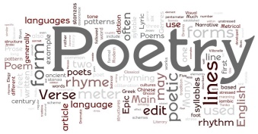
Easter Poetry Project – Year 6
Hello Goostrey pupils, we are so pleased with the way you are working at home. As the Easter holidays are approaching, the teachers will not set work on the homework pages for two weeks. However, we would like to give you a mini project.
Mini Project
We would like you to learn a poem off-by-heart, from the five chosen below.
When we finally get back to school, we will perform then in class (maybe to the school).
There is a choice of 5 poems. You need to pick one to learn.
Here are the choices - open each one as a PowerPoint to see why it has been chosen.
Choice | Poem
1 | Colonel Fazackerley Butterworth Toast – Charles Causley
2 | Matilda – Hillaire Belloc
3 | Timothy Winters – Charles Causley
4 | Jabberwocky – Lewis Carroll
5 | The Witches Spell – William Shakespeare

You must learn one from the five above.
You may learn more than one if you wish.
If you want to you can also choose a poem not from the list and learn that as well.
Louise Timmins & Carol Cooper (who will also be learning one from the above.)
