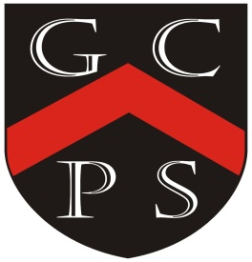

**Art and Design Map For Goostrey 2024-25**

More detailed plans including our Year Plans, Knowledge Organisers, vocabulary, timelines, teaching points and weekly class information to be found on individual class pages.

Drivers

For Our Curriculum:

*Excellence Inclusivity Community Diversity Challenging Reflective*

For Our Pupils:

*Knowledgeable Motivated Curious Healthy Resilient Independent Creative*

|  |  |
| --- | --- |
| *Year Group* | *Coverage Over The Year* |
| *1* | Painting and colour mixing and collage  Display work  Exhibition- Art skills- drawing  Pastel animals  Collage  Penguin collage/ Purple Mash art programme Penguins  Brusho painting  Drawing  Different lines and thickness  Kandinksy inspired art- hot and cold colours |
| *2* | Linked to Exhibition  Collages/construction  Painting and drawing  Ink and watercolour  Famous Artists – create work in their style – Andy Warhol printing  Famous Artists linked to  Great of London  Famous Artists – create work in their style – Paul Klee |
| *3* | * Drawing and painting artwork related to African animals * Printing – African surface pattern design two colours using tiles and string. * Landscapes painting, inspiration from the Greats, French Impressionists * Based on class book - **Fox –** Margaret Wild & Ron Brooks * Develop ideas from starting points, comment on artworks using visual language, annotate sketches to explain and elaborate ideas. * Use watercolour paint to produce washes for backgrounds then add detail. * Experiment with creating mood with colour. * Purple Mash Mosiac programme * Sketching skills, focusing on the hardness of the pencils. * Sculpt Roman style pottery from air-dry clay |
| *4* | Drawing/Painting  Mountains (HT – mountain art)  Printing  Runic patterns  Brooch - Sutton Hoo  Textiles  Money purses  Digi media  Pop Art |
| *5* | Exhibition - Textiles  Henry Moore: Blitz Paintings  Georgia O’Keefe Still life – flowers |
| *6* | Drawing, Painting and Sculpture  Digital Media  Collage  Printing  Stone Age art  Hats - Textiles |