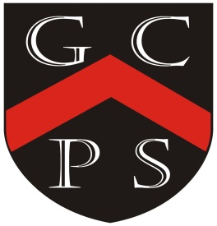

**Geography Map For Goostrey 2024-25**

More detailed plans including our Year Plans, Knowledge Organisers, vocabulary, timelines, teaching points and weekly class information to be found on individual class pages.

Drivers

For Our Curriculum:

*Excellence Inclusivity Community Diversity Challenging Reflective*

For Our Pupils:

*Knowledgeable Motivated Curious Healthy Resilient Independent Creative*

|  |  |
| --- | --- |
| *Year Group* | *Coverage Over The Year* |
| *1* | Investigate seasonal variations – wonderful weather.  Where have I been and what have I seen?  Communicate geographically- human and physical features.  identify the location of cold areas in relation to the Equator and the North and South Pole.  Linked to Captain Scott  Observe and study our school grounds and environment of our location.  Investigate Goostrey school compared to Elizabethfontein school  Look at South Africa in relation to equator. |
| *2* | Chronology Unit and links to local area:  Homes through the ages  The Great fire of London  Samuel Pepys   1. Leading lights in Medicine   Florence Nightingale  Mary Seacole  Marie Curie  Castles |
| *3* | * **Human and physical geography,**   U.K. focus   * Name and locate counties and cities of the United Kingdom, geographical regions and their identifying human and physical characteristics, key topographical features (including hills, mountains, coasts and rivers). * Describe the UK in terms of Africa (in relation to our twinned school) using compass points, hemispheres and tropics.   Research the climate and use cross-curricular learning to represent finding such as graphs and charts.  **Communicate geographically:** Describe key aspects of:   * volcanoes and earthquakes – tectonic plates * Where are volcanoes predominantly found? * How do they occur? * Types of volcanoes * What is an earthquake and how do they occur? * **human geography**, including: settlements and land use.   **Focus in on EF**  Local environment – school and surrounding area – compare to life and surroundings of Elizabethfontein |
| *4* | Mountains  Focus on Everest and Asia  Map work – relief including contours  UK – linked to Anglo-Saxons and Vikings  Europe  Physical and human features  Countries, capitals and contrasts |
| *5* | Rivers  Burwardsley (Map, Compass, Grid work)  South America |
| *6* | Locational knowledge  Physical geography – biomes and climate zones  Links with Elizabethfontein  North America  Map Reading  North America  Map Reading |